**IPv4 MAC:**

**Instructions for setting up raspberry pi:**

**Installing appropriate Drivers and Modules:**

1. **Download and install OS**

**Link**: [Raspberry Pi image](https://www.raspberrypi.org/downloads/raspbian/) (Raspbian Stretch Desktop 2018-04-18)

**Link**: [Flashing software](http://www.raspberry-projects.com/pi/pi-operating-systems/win32diskimager) Wind32imanger

**Link**: Raspberry Pi image with functional 2.0 Charge Cart software

1. **Functional application**

S:\EE Systems Integration & Validation\K1 2.0 Test Bench\Charging Bench

Copy folder to /home/pi

1. **Install python 3 and python-can library**

sudo apt-get install python3-pip

sudo pip3 install python-can

1. **Install compatible gcc g++ version**

sudo apt-get install -y gcc-4.9 g++-4.9

sudo update-alternatives --install /usr/bin/gcc gcc /usr/bin/gcc-4.9 100 --slave /usr/bin/g++ g++ /usr/bin/g++-4.9

sudo update-alternatives --install /usr/bin/gcc gcc /usr/bin/gcc-4.9 50

sudo update-alternatives --config gcc g++

1. **get & install kernel headers:**

git clone <https://github.com/notro/rpi-source>

cd rpi-source

chmod +x rpi-source

sudo apt-get install bc

./rpi-source

1. **get & install PEAK drivers:**

wget <http://www.peak-system.com/fileadmin/media/linux/files/peak-linux-driver-8.5.1.tar.gz>

tar -xzf peak-linux-driver-8.5.1.tar.gz

cd peak-linux-driver-8.5.1

1. **install required dependencies (peak-driver):**

sudo apt-get install libpopt-dev # build chardev driver

make PCI=NO PCIEC=NO PCC=NO DNG=NO PAR=NO ISA=NO NET=NETDEV_SUPPORT

sudo make install

sudo modprobe pcan

1. **check PEAK devices: (**NOTE: if run into error: no command found. Redo step 5 and step 6, but redownloading the peak can driver is not required)

cat /proc/pcan

check if can0 appears on the terminal window as follow

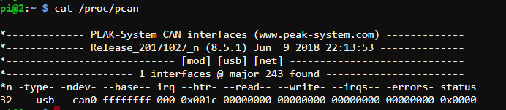

**Installing library for GUI**

1. **Install tkinter and dependencies for python3**

sudo apt-get install –y libopenjp2-7 python3-tk

1. **Install pillow**

sudo pip3 install pillow

1. **Install xutils**

sudo apt-get install –y xutils

1. **Disable Screen timeout**

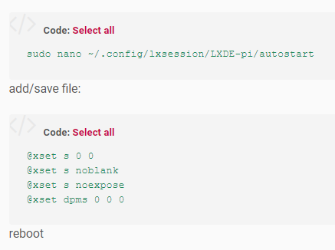

**Copy the two files to execute the code on the desktop and make them executable (exe.sh & AC_Cart_New.py):**

1. Make the exe.sh file executable by entering the following command on the command line while the directory is on the “Desktop” (enter command “**cd /home/pi**” if not on desktop directory):

**sudo chmod +x launch_app.sh**

1. Make the AC_Cart_New.py executable by entering the following command line while the directory is on the “Desktop” (enter command “**cd full_stack**” if not on desktop directory):

**sudo chmod +x main.py**

**launch_app.sh:**

#!/bin/bash

sudo ip link set can0 up

cd full_stack

sudo /usr/bin/python3 /home/pi/full_stack/main.py

**Edit the bashrc file on the raspberry pi to execute the program on startup:**

1. On the terminal enter the following command:

sudo nano /etc/bash.bashrc

1. Scroll to the bottom of the file and enter the following code :

sudo /home/pi/launch_app.sh &

1. Open the autostart config with this command:

sudo nano /home/pi/.config/lxsession/LXDE-pi/autostart

1. Add the following line

@lxpanel --profile LXDE-pi

@pcmanfm --desktop --profile LXDE-pi

@xscreensave –no-splash

@point-rpi

@lxterminal

1. Then hit ctrl+x and y to save and exit.
2. This command in the bashrc file will allow the pi to execute the program at startup and will prevent any input to start the program.